“The ability to transform any space temporarily into a smart space is a powerful capability”. What are successful implementations of smart spaces? Should the implementation of physical smart spaces be entirely replaced by transient smart spaces (i.e. with smart mobile devices/artefacts)?

Table of Contents

1. Introduction 3

2. Existing and Successful Implementations 3

2.1 Physical Smart Spaces 3

2.2 Transient Smart Spaces 5

3. Similarities and Differences: Physical vs. Transient Smart Spaces 7

4. Evaluation of physical Smart Spaces 8

5. Evaluation of transient Smart Spaces 8

6. Conclusion 8

# 1. Introduction

Smart devices have been established as viable everyday gimmicks, but what exactly is a smart device? Based on a Google search, a smart device is a device able to communicate with its surrounding devices via a connecting technology, i.e. Bluetooth, Wi-Fi, NFC and so on. To simplify the search’s definition of a smart device, it is a device that can think; a device with an embedded processor, of any speed and frequency which is wireless capable, with examples such as a smartwatch, a smartphone or a smart TV. However, this are just a subset of the now common entity, the Internet of Things. This leads us to our next definition, that of a smart space and this report’s main concern. A smart space is a space where smart devices and integrated sensors are surrounding the perimeter, communicating with each other over a dedicated network, processing data, analysing the environment/users and eventually allowing users to live an easier life by gathering everything a user can control in a single interface as Cook et al suggest, (Cook and Das, 2005). Nonetheless, this does not necessarily mean that data cannot be fetched or sent from or to a device outside the boundaries of this space. In fact, in the context of smart spaces, the word space is only meant to describe a confound environment, but does not limit the reachability and extend of communication with devices in remote locations.

The main idea governing this essay is based on the words of Mahadev Satyanarayanan, the founding Editor in Chief of IEEE Pervasive Computing, (Ebling and Want, 2017). He suggests that being able to transmute any space into a smart space transiently is a prevailing functionality. Focusing on the conceptual meaning of these disputes, comes our next and final definition. A transient smart space is, as the name suggests, a temporary solution to having physical smart space capabilities on the go; a subset of physical smart spaces. That is, with the use of mobile (portable) devices and artefacts that are themselves smart, but are not limited by input from stationary sensors. Alternatively, these artefacts are able to distinguish their surroundings and perform a task that will eventually allow the user to temporarily transform a “non-smart” space into a functioning smart space.

# 2. Existing and Successful Implementations

Physical smart spaces are still a work in progress, and currently not everyone can afford one. This is not entirely true when the smart space is considered a transient one or a partial physical smart space. A transient smart space will have limited capabilities depending on the user’s request, but will eventually do what the user requires. As for a partial physical smart space, this means that the environment is not surrounded fully by sensors and other devices, but instead is supplied with only the necessary appliance to work in the confound environment. Difference and similarities can be reviewed below.

## 2.1 Physical Smart Spaces

Physical smart spaces must be deployed correctly, all the sensors, and the server and other input devices must be set accordingly with the consumer as the person of interest, and the degree of complexity can range from low to extremely high, (Ricquebourg et al., 2006). A lot of information can be found on certain companies that are specialising in making the consumer’s desired environment permanently smart. Loxone is one such company, by advertising their expertise on renovating any space to include cutting edge technology, and focuses mainly on energy consumption and sustainability, (Loxone Smart Home Automation UK, 2017). Specifically, some of this company’s work, consists of revamping homes, offices and, in one case, a church, with their ultimate goal being making these places smart. How they do it is what separates this company from its competition. Setting up such an interactive environment requires expertise, knowledge and technical abilities, by interconnecting various sensors, for temperature, humidity, proximity with users and other various technicalities. Additionally, a successful physical smart space would be transparent to the user, and Loxone is doing exactly that, by hiding the wiring and placing the numerous sensors in places where they are unreachable and invisible. When dealing with homes, Loxone sets up the dedicated network, interconnecting the technology, such as smart thermostats, smart blinds, smart bulbs and other smart devices, then moves on to configuring the user interface and finally providing the designated users with an application on their smartphone, to control all of these capabilities which are connected on the brains of the operation, a “mini” server. Since their birth, Loxone also had the task of making a smart church. The set up for the church, closely resembles that of a smart home. Churches on the other hand, are public spaces, and are vulnerable to thefts. For this purpose, Loxone, supplied the church with a new system, using their words, “Due to this constant threat, this church is [protected via the Loxone Smart Home system](https://www.loxone.com/enen/smart-home/security/). In the case of a burglary, the lights in the church begin to flash and a loud siren begins to wail, exposing the intruder. The church caretaker is also immediately notified through a call to his phone and push notification via the Loxone Smart Home App”. This entails that they reinforced the security measurements to apply on a public space. Needless to say, a full Loxone makeover of any space costs a considerably large amount given the labour of connecting everything together. Figures 1 and 2, show an example of a smart home and the case of the church respectively. Figure 3 show the interconnected devices on a wired network.

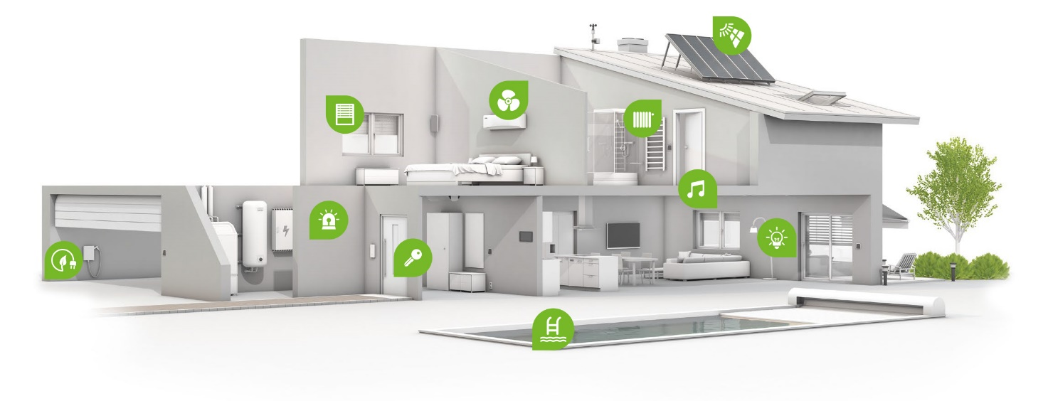

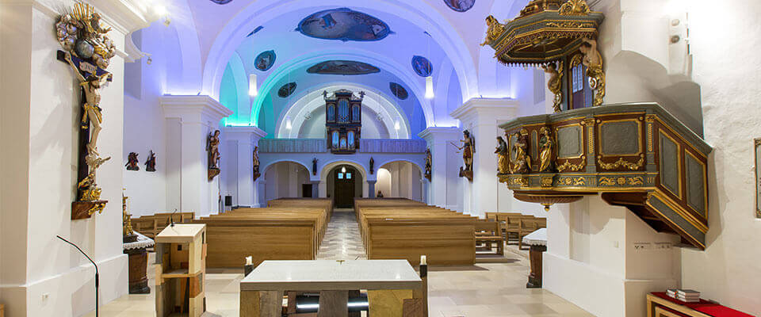

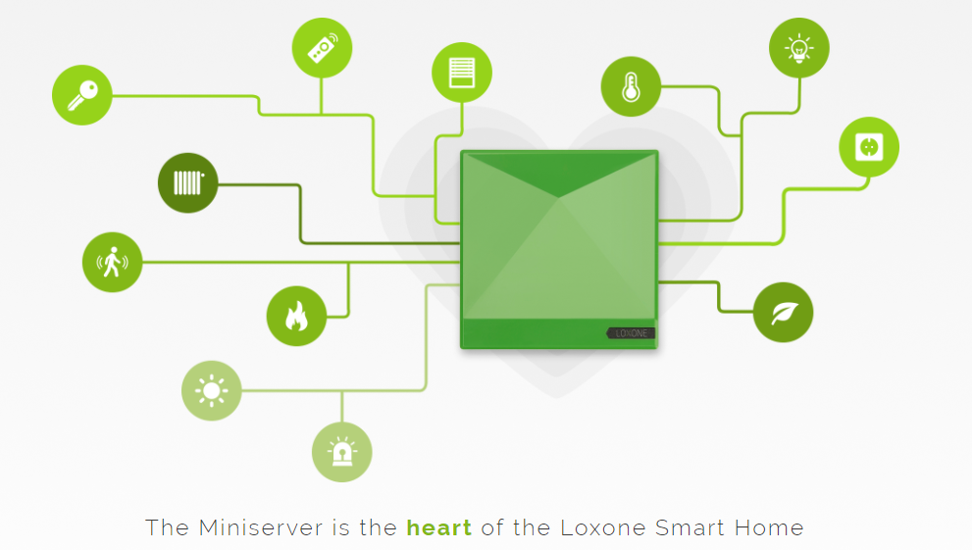

## 2.2 Transient Smart Spaces

Transient smart spaces are not as straightforward as physical smart spaces since they are just abstract. This is due to the fact that a physical smart space by nature has multiple permanently stationary components, sensors, that have a dedicated task, provide data as input, whereas a transient smart space, is a space where wirelessly connected smart devices have to coincide to perform a task, or work independently to perform a more specific task. Therefore, the following paragraphs will emphasize mostly on the devices that could be used to set up a transient smart space.

First off, a potential smart device is the Lenovo Yoga Tab 3 Pro, which can be used either as a tablet, a personal computer or even a projector, which is itself integrated and can be rotated to the user’s liking. With this power, the Yoga Tab 3 pro, can project any image or video on a wall up to 70 inches large in diagonal. That is extremely impressive when you realise that all of this is packed in a 10-inch tablet only a few mm in thickness. A powerful projector is retailed at about twice the price of this tablet, which is perfect for travelling and it is probably a fraction of the projector’s weight and size. As Lenovo advertises, it is a tablet that can actually replace a TV.

Considering the temporary aspect of a transient smart space, Amazon Echo Dot could be considered an immediate candidate for the brains of the network. With the digital assistant Alexa, a user can interact with multiple communicating smart devices such as smart light bulbs, e.g. Phillips Hue Starter Kit, or smart thermostats, e.g. Nest Learning Thermostat or speakers and smart TVs, all with the power of the user’s voice. Alexa is voice activated and can perform millions of tasks, just by saying “Alexa, do that…”, but with a single important hindrance; a user must buy a lot of smart devices to successfully turn a space into a smart space. This entails that a user must have bought the smart light bulbs and set them up using the Amazon Alexa app, to eventually be able to dim the lights or switch them completely off.

A final example device that is able to mimic the capabilities of a smart space temporarily is Google Chromecast. With Chromecast, one could turn any TV or monitor, to a smart TV, given that the TV has an HDMI port. Then, using a smart phone or tablet, the user can replicate the contents of their device’s screen by mirroring everything on a standard TV, and all that’s required is wireless network. As long as the smartphone and Chromecast are connected to the same network wirelessly, anything can be done, ranging from listening to Spotify, watching YouTube or Twitch streams or even looking through cook book recipes while cooking.

Figures 4, 5 and 6, show all of the above-mentioned devices.

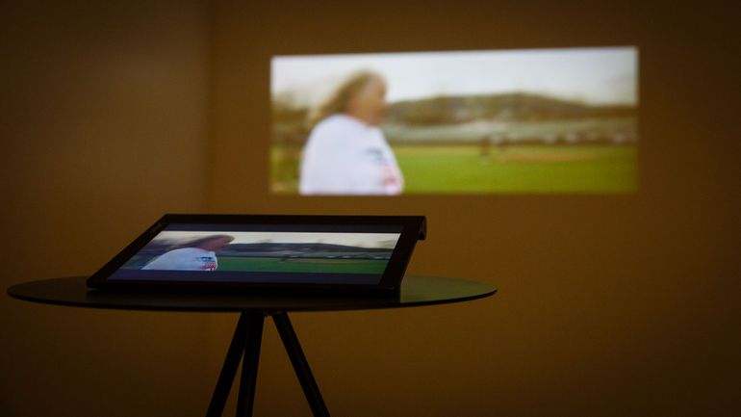

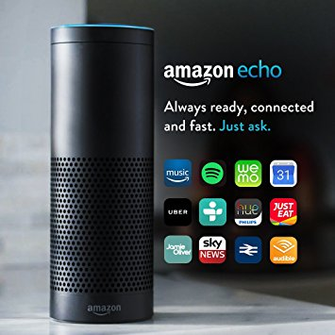

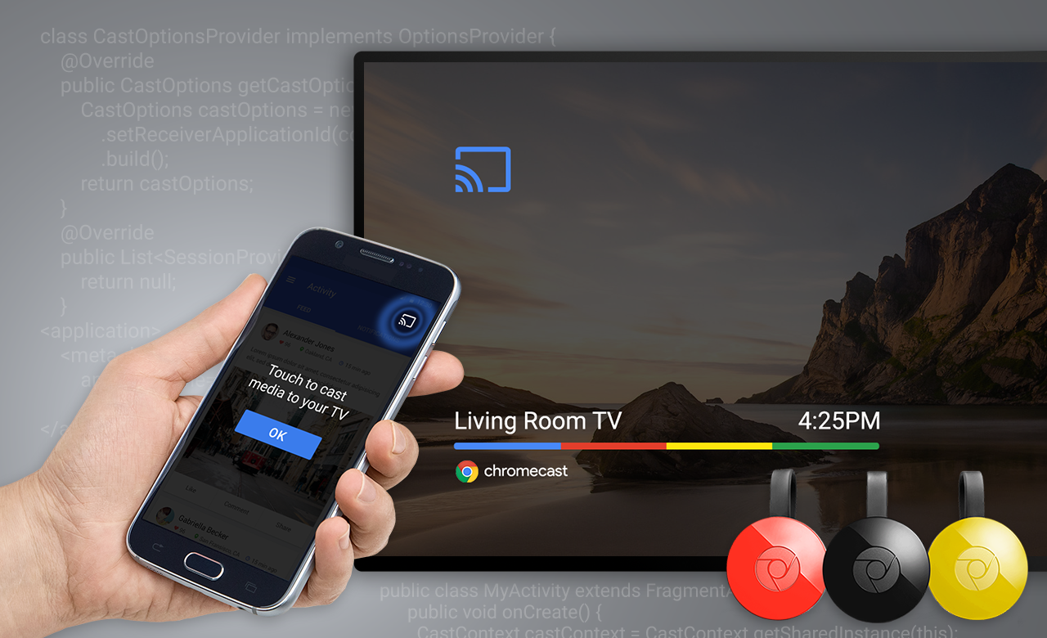

# 3. Similarities and Differences: Physical vs. Transient Smart Spaces

It is hard to categorise between physical and transient smart spaces given their many similarities and differences, since they are used as per the situation at hand. If a user wants to live comfortably in a smart environment of his/her own, then transforming the space to a smart space temporarily is not an option. Considering that the user will want to have such luxuries throughout his/her life then a permanent solution is the most efficient in such scenarios. However, if for some reason the user travels frequently, then the temporary solution is much more effectual. Based on the time and effort required to set up a physical smart space such as the ones mentioned by Loxone, a user moving continuously will consider this as obsolete, but will more probably stick with a personal transient smart space consisting of the devices the user possesses and can carry.

One example is a trip to a family summer home. The family will not even consider bringing a TV with them but will, definitely, bring along their Lenovo Yoga Tab 3 Pro. This will allow them to have a big enough screen for all of them to enjoy movie night. On the other hand, if the family will stay over 3 months to their summer home and they can afford transforming it into a super smart space then, by all means, the physical smart space may as well be the better choice. Following on this comparison, one can imagine the difference in price of these alternative smart spaces. This depends also on the capabilities of the imposed smart space.

A classroom can be transformed into a physical smart space just by installing a smart whiteboard. Alternatively, the teacher could have a big screen and with the use of a Chromecast, mirror the contents of his/her laptop screen as he/she moves through the slides and with the use of a stylus, write some extra notes; transient smart space. Eventually, these two alternatives, are customised to perform the same task. What happens though if the classroom was not supplied with a large enough monitor or a wireless Internet connection? Then the teacher would be unable to connect using a Chromecast, and the possibility of carrying a TV on the go is out of the question. Instead with a smart whiteboard the above scenarios are still applicable as the whiteboard would not require an internet connection, while using the embedded projector to produce a large enough display. This entails that physical smart spaces are, most of the time, more reliable, supplying functionalities without any requirements from the outside environment, while a transient smart space, due to its notion of being on-the-go able, depends greatly on a continuous internet connection at hand to perform communication with surrounding devices, as well as the power consumption issue with any battery powered device. Every artefact involved in a transient smart space must have a mind of its own, due to the fact that there is no central brain as in a physical smart space (Loxone MiniServer). Nonetheless, with Amazon Echo Dot you get a Brain but in order to communicate with the multiple smart artefacts it requires a 24/7 internet connection as well.

A major difference worth mentioning is the audience. “Physical spaces are packed with opportunities, complexities, and of course, people”, (Helal and Tarkoma, 2015); this statement is, without a doubt, very true and realistic. When designing and setting up a physical smart space, the supplier knows how many people will be using the facilities on a daily basis. For example, transforming an office into a smart space, then there are going to be 20-30 people for 8 hours daily, lurking the premises. Therefore, the supplier will take into consideration this amount and customise the set up appropriately. On the other hand, as the setup of a transient smart space depends solely on the user’s needs, a more personal approach is considered. A transient smart space works better for a limited number of people, say 4-5 family members. More precisely, the user will probably customise the smart environment to use it alone but with the ability to expand given more devices to enter the same network.

# 4. Evaluation of physical Smart Spaces

# 5. Evaluation of transient Smart Spaces

# 6. Conclusion

Looking back at the words of Mahadev Satyanarayanan, one can now embrace the ultimate meaning of this phrase. First of all, one must clarify the time span of the word “temporary”, as this may mean for a few hours, a few days, or a few months. Nonetheless, Mahadev probably meant for a few hours, as given some of the examples he uses, such as the projectable keyboard on any surface, (Wang et al., 2014). That keyboard is very useful given that users are not required to carry a keyboard wherever they commute to, but constantly using that keyboard over any other keyboard would be uncomfortable and tiring. Reading this essay everyone would have a different opinion on whether transient smart places would be the optimal solution, but these two alternatives have their own positives and negatives.